**Experiment-4**

**Aim**: Design a LED blinker using push button

**Apparatus**: Arduino,LED,resistors,wires,breadboard,push button,buzzer

**Circuit**:

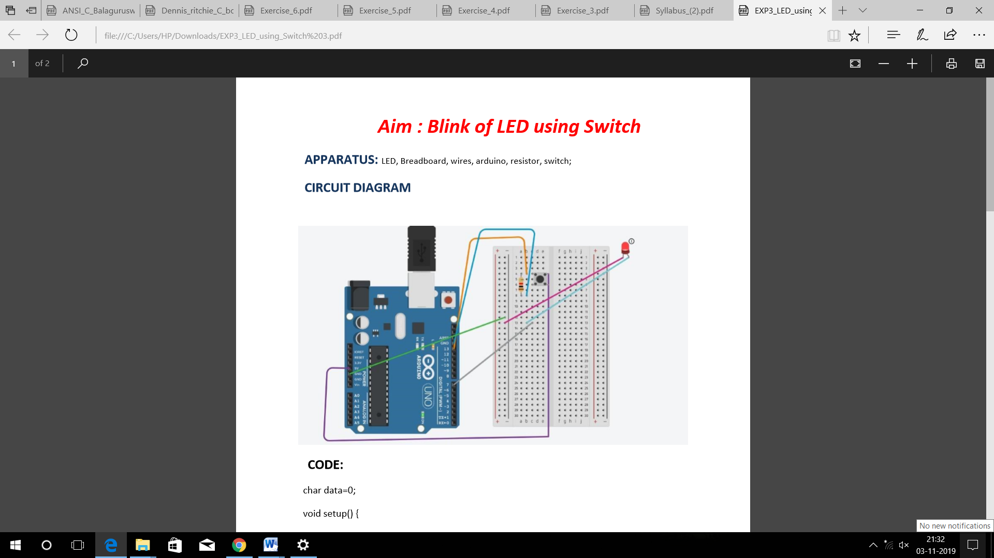

**Program**:

char data=0;

void setup()

{

Serial.begin(9600);

pinMode(1,OUTPUT);

}

void loop() {

if(Serial.available()>0)

{

data=Serial.read();

Serial.print(data);

Serial.print("\n");

if(data=='1')

digitalWrite(13,HIGH);

else if(data=='0')

digitalWrite(13,LOW);

}

}

**Precautions**:

* Connections should be tight.
* Delay gap should be sufficient.

**Result** :

The LED will glow when we press the switch

**Learning and Observations**:

1. A push button switch and LED is connected to arduino.

2. When we press the switch, LED will glow for 1 second.

3. You need to connect pull up or pull down resistor while interfacing switch.

**Sources of errors**:

1. Arduino may not work properly and cables can also create problem.

2. Mistake in code uploading.